Name: Monisha G
Reg No:192411020
Course code and Name: CSA0923- Programming in Java
ASSESMENT TOOL 1-CODING CHALLENGE
1. Library Book Management using Classes
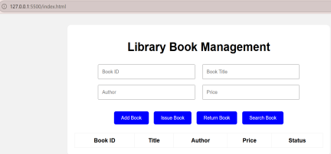
2. Employee Payroll System using
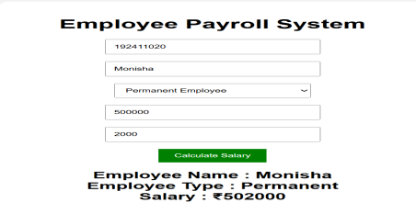
3. Vehicle Rental System using Runtime
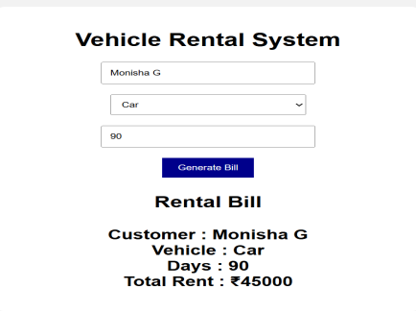
4. Bank Account System
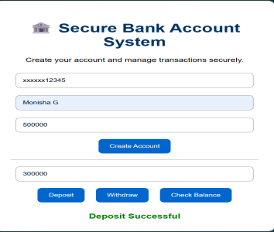
5. University Admission System
